1. Do we also have water inside the earth? If yes, how and in which form?

Ans : Yes, water is present inside earth.It is present in more than one form and it is considered that deep inside the earth , it exists in Hydroxyl ions and oxygen due to high pressure and high temperature.

Ground water is present beneath’s earth surface in soil poures and cracks of rocks.

Water is also present in earth’s mantle and wikipedia says that the amount is equal to all water present in oceans.The proof of presence of water in earth’s mantle was found in 2014 andfrom samples of ringwoodite(liquid water was not present rather than com[onents of water).

The presence of water in earth’s mantle makes it difficult to the explaination of origin of earth’s water. This(https://www.quantamagazine.org/the-hunt-for-earths-deep-hidden-oceans-20180711/) articles states that their are atleast two mechanisms that are responsible for it which is depicted by this picture :

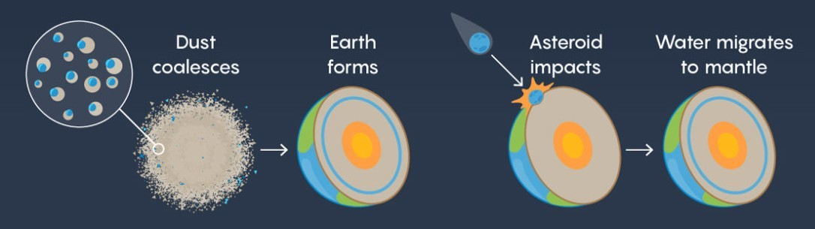1) As earth formed from dust and rock , some water molecules stuck to dust and survived the heat of solar sytem.

2) Water-rich asteroids from the distant solar system crash into earth and this water was slowly absorbed by the mantle.

2. Suggest three major human activities which are (has been) altering the earth.

Ans : Their are many human activities which are altering the earth :

* Over-population (which also leads to overconsuption of resources eg : deforestation)Fishing and Farming(Changes quality of soil and water)
* Releasing excess greenhouse gases, burning of fossile fuels (leads to increase in temperature and thus rising sea level)

3. Suggest three slow and three fast natural processes that can affect the Earth’s dynamics.

Ans : Slow natural processes : Weathering,erosion,movement of tectonic plates.

Fast natural processes : Tsunamis,earthquakes,volcanic eruptions.

4. Not every planet has a Geodynamo, why? If Earth did not have a magnetic field, what might be different about our planet?

Ans : Wikipedia says : “The dynamo theory describes the process through which a rotating, convecting, and electrically conducting fluid can maintain a magnetic field over astronomical time scales.”

Planetary magnetic fields are formed by the interaction between the convection of interior conducting material (molten rock and metal) and the planet’s own rotation. Mercury’s field is weak because it rotates so slowly. Venus doesn’t have an appreciable field because there appears to be little convection in its molten interior. Mars doesn’t have an appreciable field – although it did in the past – because its interior has solidified.